I am going to use regression, decision trees, and the random forest algorithm to predict combined miles per gallon for all 2019 motor vehicles.  The raw data is located on the [EPA government site](https://www.fueleconomy.gov/feg/download.shtml)

After preliminary diagnostics, exploration and cleaning I am going to start with a multiple linear regression model.

The variables/features I am using for the models are: Engine displacement (size), number of cylinders, transmission type, number of gears, air inspired method, regenerative braking type, battery capacity Ah, drivetrain, fuel type, cylinder deactivate, and variable valve.

There are 1253 vehicles in the dataset (does not include pure electric vehicles) summarized below.

fuel_economy_combined eng_disp num_cyl transmission  
 Min. :11.00 Min. :1.000 Min. : 3.000 A :301   
 1st Qu.:19.00 1st Qu.:2.000 1st Qu.: 4.000 AM : 46   
 Median :23.00 Median :3.000 Median : 6.000 AMS: 87   
 Mean :23.32 Mean :3.063 Mean : 5.533 CVT: 50   
 3rd Qu.:26.00 3rd Qu.:3.600 3rd Qu.: 6.000 M :148   
 Max. :58.00 Max. :8.000 Max. :16.000 SA :555   
 SCV: 66   
 num_gears air_aspired_method  
 Min. : 1.000 Naturally Aspirated :523   
 1st Qu.: 6.000 Other : 5   
 Median : 7.000 Supercharged : 55   
 Mean : 7.111 Turbocharged :663   
 3rd Qu.: 8.000 Turbocharged+Supercharged: 7   
 Max. :10.000   
   
 regen_brake batt_capacity_ah   
 No :1194 Min. : 0.0000   
 Electrical Regen Brake: 57 1st Qu.: 0.0000   
 Hydraulic Regen Brake : 2 Median : 0.0000   
 Mean : 0.3618   
 3rd Qu.: 0.0000   
 Max. :20.0000   
   
 drive cyl_deactivate  
 2-Wheel Drive, Front :345 Y: 172  
 2-Wheel Drive, Rear :345 N:1081  
 4-Wheel Drive :174   
 All Wheel Drive :349   
 Part-time 4-Wheel Drive: 40   
   
   
 fuel_type   
 Diesel, ultra low sulfur (15 ppm, maximum): 28   
 Gasoline (Mid Grade Unleaded Recommended) : 16   
 Gasoline (Premium Unleaded Recommended) :298   
 Gasoline (Premium Unleaded Required) :320   
 Gasoline (Regular Unleaded Recommended) :591   
   
   
 variable_valve  
 N: 38   
 Y:1215

Call:  
lm(formula = fuel_economy_combined ~ eng_disp + transmission +   
 num_gears + air_aspired_method + regen_brake + batt_capacity_ah +   
 drive + fuel_type + cyl_deactivate + variable_valve, data = cars_19)  
  
Residuals:  
 Min 1Q Median 3Q Max   
-12.7880 -1.6012 0.1102 1.6116 17.3181   
  
Coefficients:  
 Estimate Std. Error t value Pr(>|t|)   
(Intercept) 36.05642 0.82585 43.660 < 2e-16 ***  
eng_disp -2.79257 0.08579 -32.550 < 2e-16 ***  
transmissionAM 2.74053 0.44727 6.127 1.20e-09 ***  
transmissionAMS 0.73943 0.34554 2.140 0.032560 *   
transmissionCVT 6.83932 0.62652 10.916 < 2e-16 ***  
transmissionM 1.08359 0.31706 3.418 0.000652 ***  
transmissionSA 0.63231 0.22435 2.818 0.004903 **   
transmissionSCV 2.73768 0.40176 6.814 1.48e-11 ***  
num_gears 0.21496 0.07389 2.909 0.003691 **   
air_aspired_methodOther -2.70781 1.99491 -1.357 0.174916   
air_aspired_methodSupercharged -1.62171 0.42210 -3.842 0.000128 ***  
air_aspired_methodTurbocharged -1.79047 0.22084 -8.107 1.24e-15 ***  
air_aspired_methodTurbocharged+Supercharged -1.68028 1.04031 -1.615 0.106532   
regen_brakeElectrical Regen Brake 12.59523 0.90030 13.990 < 2e-16 ***  
regen_brakeHydraulic Regen Brake 6.69040 1.94379 3.442 0.000597 ***  
batt_capacity_ah -0.47689 0.11838 -4.028 5.96e-05 ***  
drive2-Wheel Drive, Rear -2.54806 0.24756 -10.293 < 2e-16 ***  
drive4-Wheel Drive -3.14862 0.29649 -10.620 < 2e-16 ***  
driveAll Wheel Drive -3.12875 0.22300 -14.030 < 2e-16 ***  
drivePart-time 4-Wheel Drive -3.94765 0.46909 -8.415 < 2e-16 ***  
fuel_typeGasoline (Mid Grade Unleaded Recommended) -5.54594 0.97450 -5.691 1.58e-08 ***  
fuel_typeGasoline (Premium Unleaded Recommended) -5.44412 0.70009 -7.776 1.57e-14 ***  
fuel_typeGasoline (Premium Unleaded Required) -6.01955 0.70542 -8.533 < 2e-16 ***  
fuel_typeGasoline (Regular Unleaded Recommended) -6.43743 0.68767 -9.361 < 2e-16 ***  
cyl_deactivateY 0.52100 0.27109 1.922 0.054851 .   
variable_valveY 2.00533 0.59508 3.370 0.000775 ***  
---  
Signif. codes: 0 ‘***’ 0.001 ‘**’ 0.01 ‘*’ 0.05 ‘.’ 0.1 ‘ ’ 1  
  
 standard error: 2.608 on 1227 degrees of freedom  
Multiple R-squared: 0.8104, Adjusted R-squared: 0.8066   
F-statistic: 209.8 on 25 and 1227 DF, p-value: < 2.2e-16

The fitted MSE is 6.8 and predicted MSE of 6.83.  Some of the below residuals are too large.  The extreme large residual is a Hyundai Ioniq which none of the models predict very well as it is unique vehicle (versus the other data points).

[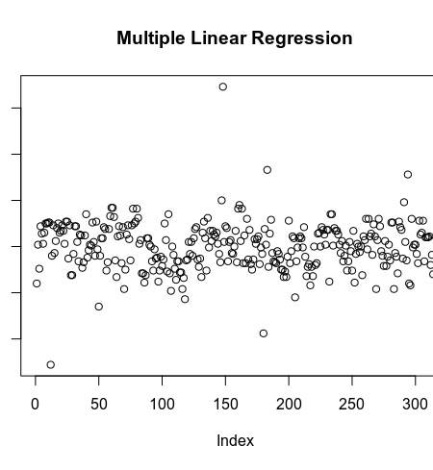](https://i2.wp.com/s3-us-west-1.amazonaws.com/alpha-analysis.com/Pictures/MPG/mlr_residuals.png?ssl=1)

Let’s try a decision tree regression model.

#regression tree full  
m_reg_tree_full <- rpart(formula = fuel_economy_combined ~ .,  
 data = train,  
 method = "anova",)  
#regression tree tuned  
m_reg_tree_trimmed <- rpart(  
 formula = fuel_economy_combined ~ .,  
 data = train,  
 method = "anova",  
 control = list(minsplit = 10, cp = .0005)  
)  
  
#rpart.plot(m_reg_tree_full)  
plotcp(m_reg_tree_full)  
  
pred_decision_tree_full <- predict(m_reg_tree_full, newdata = test)  
mse_tree_full <- RMSE(pred = pred_decision_tree_full, obs = test$fuel_economy_combined) ^2  
  
pred_decision_tree_trimmed <- predict(m_reg_tree_trimmed, newdata = test)  
mse_tree_trimmed <- RMSE(pred = pred_decision_tree_trimmed, obs = test$fuel_economy_combined) ^2  
plotcp(m_reg_tree_trimmed)

[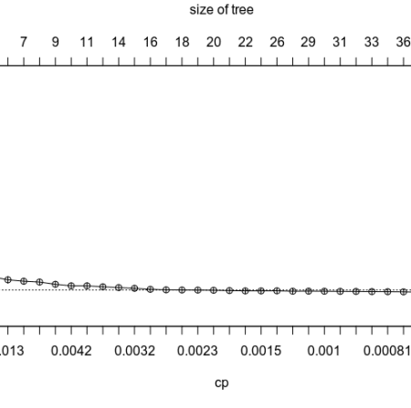](https://i2.wp.com/s3-us-west-1.amazonaws.com/alpha-analysis.com/Pictures/MPG/decision_tree.png?ssl=1)

After tuning the decision tree the predicted MSE is 6.20 which is better than the regression model.

Finally let’s try a random forest model.  The random forest should produce the best model as it will attempt to remove some of the correlation within the decision tree structure.

#random forest  
m_random_forest_full <-randomForest(formula = fuel_economy_combined ~ ., data = train)  
predict_random_forest_full <- predict(m_random_forest_full, newdata = test)  
mse_random_forest_full <- RMSE(pred = predict_random_forest_full, obs = test$fuel_economy_combined) ^ 2  
  
which.min(m_random_forest_full$mse)  
  
#random forest tuned  
m_random_forest <- randomForest(formula = fuel_economy_combined ~ ., data = train, ntree = 250)  
plot(m_random_forest)  
predict_random_forest <- predict(m_random_forest, newdata = test)  
mse_random_forest <- RMSE(pred = predict_random_forest, obs = test$fuel_economy_combined) ^ 2  
  
plot(tmp$test.fuel_economy_combined - tmp$r.predict_random_forrest., ylab = "residuals",main = "Random Forest")  
  
varImpPlot(m_random_forest)

[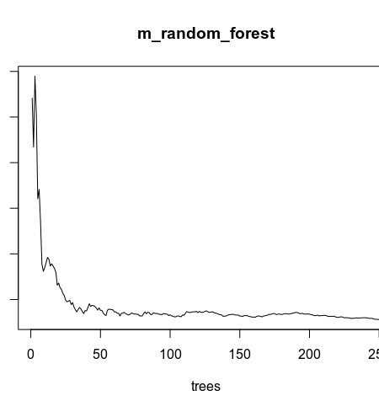](https://i0.wp.com/s3-us-west-1.amazonaws.com/alpha-analysis.com/Pictures/MPG/random_forest_error.png?ssl=1)

The error stabilizes at 250 trees.  randomForest() by default uses 500 trees which is unnecessary.

[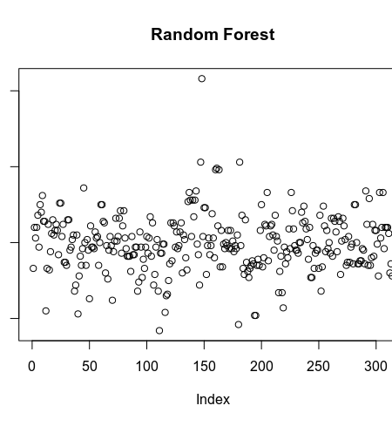](https://i0.wp.com/s3-us-west-1.amazonaws.com/alpha-analysis.com/Pictures/MPG/random_forest_residuals.png?ssl=1)

After tuning the random forest the model has the lowest fitted and predicted MSE of 3.67 which is substantially better than the MSE of the decision tree 6.2

The random forest also has an r-squared of .9

[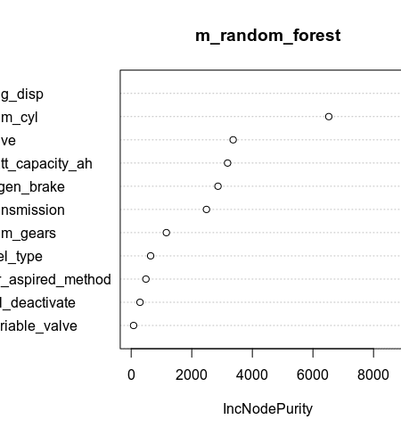](https://i1.wp.com/s3-us-west-1.amazonaws.com/alpha-analysis.com/Pictures/MPG/varimp.png?ssl=1)

Engine size, number of cylinders, and transmission type are the largest contributors to accuracy.